**Year 8 – Humanities and Social Science, Civics & Citizenship**

**Assessment 5 - Direct Action Research Task**

**Name: _______________________**

|  |  |  |
| --- | --- | --- |
| **Total marks** | **%** | **Weight** |
| PART A: **/38** |  | 7.5% |
| PART B: **/17** |  | 2.5% |

**Date Due: Week 5 Term 4**

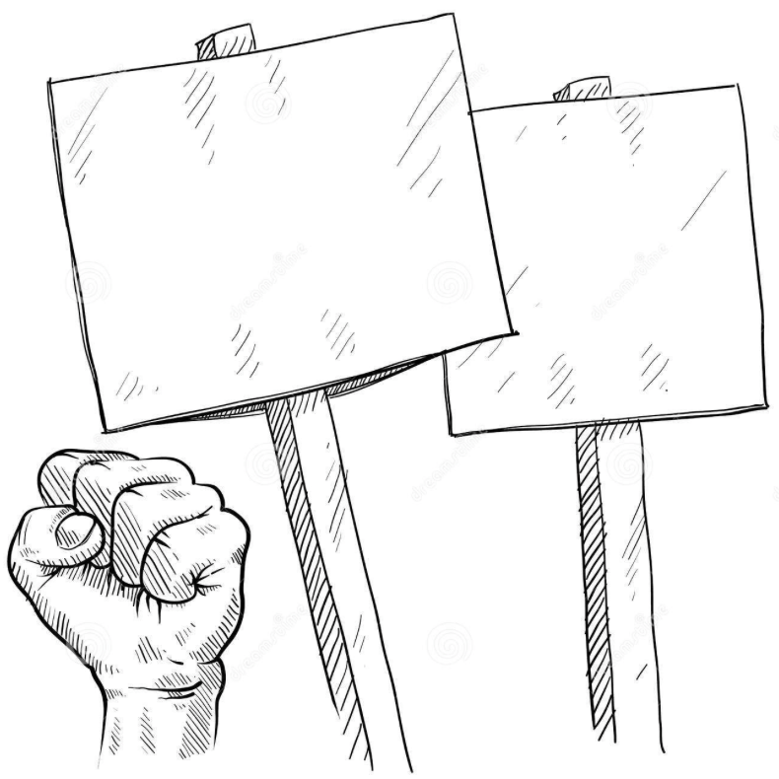**Task:**

You are to research a significant protest or social media campaign from Australia’s past. In pairs, or individually, you will then create a protest sign and write an explanation/speech as to why you are protesting. Please note; **if you are working in pairs you must each hand in a research booklet. You need to decide if you will work in a pair before research begins as you and your pair will need to research the same protest. The research process will be conducted individually.**

**PART A: Inquiry Process**

**Individually,** you must select group or individual who are or have generated change in Australia. If you want to create your protest sign in a pair, you must discuss which protest you will both research first. Your research must be completed in the attached inquiry booklet.

You must complete:

* A brainstorm on examples of direct action in Australia carried out through public demonstration or social media.
* Focus questions to guide your inquiry
* Note taking sheets
* A bibliography

**(PART B): Protest sign and speech**

**In pairs, or individually**, after completing your research, you must create a protest sign that is engaging and explains what you are protesting for or against. You must also write a speech (400-500 words) explaining your protest. You will not have to deliver your speech to your teacher or your class, however, both the protest sign and speech will be handed in and marked.

Some of this task will be completed in class with allotted computer lessons, however, it is the responsibility of the student to utilise their time both in class and at home.

**PART A**: Inquiry Booklet

1. **Brainstorm 4 marks**

Use the box provided below to brainstorm examples of direct action in Australia. This should help you determine which protest, or public demonstration, or social campaign you can base your research on. If you cannot think of many public demonstrations, take some time to do some internet/ library research before completing your brainstorm.

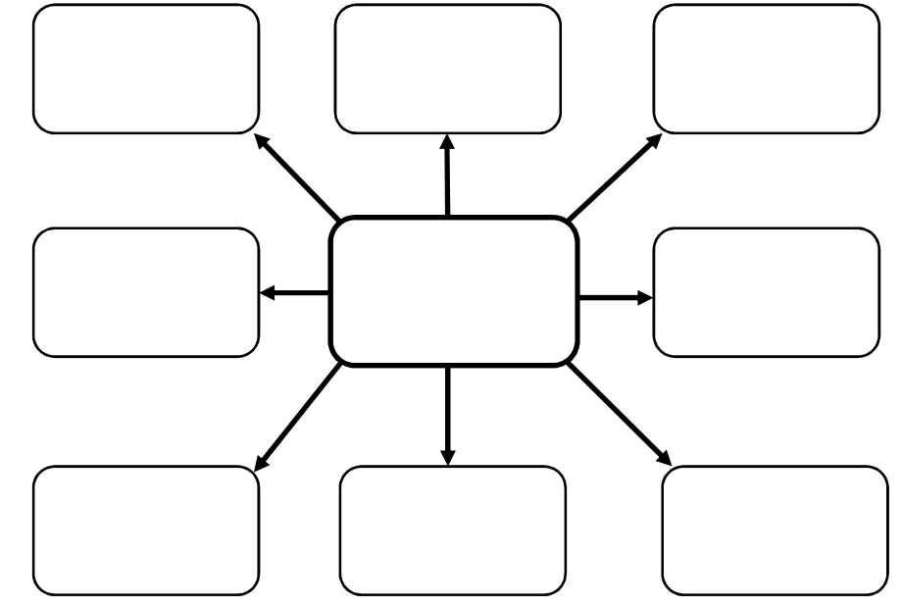

1. **Focus Questions Total: 12 mark**

Take each dot point: convert it into a specific question **(1 mark);** include details relating to your chosen public demonstration or public campaign **(1 mark)**, i.e. ‘*What is the background of the groups, or individuals, who were directly connected to the anti-war protests during the Vietnam War era of the 1960s and 1970s?*

List each of your focus questions separately at the top of each note taking page overleaf. You are expected to devise your own focus question for the sixth and last note taking sheet.

Your research must:

* Include the background of the selected group or individual
* Discuss the issue of the selected group or individual- why were they campaigning?
* List the methods used by your group or individual-social campaigning
* Effectiveness of your selected group/individual in bringing about change
* Discuss how your selected group/individuals are participating in Australia’s democracy

1. **Note taking Total:18 marks**

Recording key pieces of information that directly relate to your research is essential. Keeping that information in easily located places is equally essential. This allows you to quickly find and access what you are looking for at each stage of your project.

Use the note taking sheets overleaf to place your newly found information under the focus questions you have set yourself - so the information that you find that answers each of your focus questions, must be recoding under that focus question on its own note taking sheet.  
  
You may earn up to three marks for each set of notes you create.

The notes must be: of a volume that indicates you have done a thorough investigation and looked at numerous sources **(1 mark)**; your notes must appear as if you are organising this information in a logical and ordered manner that allows you to use them effectively later on **(1 mark)**; your notes must include information that effectively addresses the set focus question **(1 mark)**.

Focus Question 1 **2 marks**

|  |
| --- |
|  |

Key points from information sources and reference details **3 marks**

|  |
| --- |
|  |

Focus Question 2 **2 marks**

|  |
| --- |
|  |

Key points from information sources and reference details **3 marks**

|  |
| --- |
|  |

Focus Question 3 **2 marks**

|  |
| --- |
|  |

Key points from information sources and reference details **3 marks**

|  |
| --- |
|  |

Focus Question 4 **2 marks**

|  |
| --- |
|  |

Key points from information sources and reference details **3 marks**

|  |
| --- |
|  |

Focus Question 5  **2 marks**

|  |
| --- |
|  |

Key points from information sources and reference details **3 marks**

|  |
| --- |
|  |

Focus Question 6 **2 marks**

|  |
| --- |
|  |

Key points from information sources and reference details **3 marks**

|  |
| --- |
|  |

**Reference recording sheet**

*Please note that in order to obtain full marks you must submit a formal bibliography, the table below is only for recording your references as you are researching.*

|  |  |  |  |  |  |
| --- | --- | --- | --- | --- | --- |
| **Author** | **Date last updated** | **Title of Webpage** | **Date accessed** | **HTTP** | |
|  |  |  |  |  | |
|  |  |  |  |  | |
|  |  |  |  |  | |
|  |  |  |  |  | |
|  |  |  |  |  | |
|  |  |  |  |  | |
| **Author** | **Date of Publication** | **Title of Book** | **Publisher** | | **Place of Publication** |
|  |  |  |  | |  |
|  |  |  |  | |  |
|  |  |  |  | |  |

1. **Bibliography Total: 4 marks**

Recording all of the different sources you use. You must access and record a minimum of four sources to qualify for the 4 marks available.

List each source in alphabetical order, A – Z, according to the author’s surname. If there are more than two authors, list the name of the first author and add the latin term ‘et al’ afterwards, which means ‘*all the rest, or plural’*.

Each reference of a source should follow the following format:

*Author (surname and then initial of first name); then the source’s title (in italics or underlined); then the publisher (for a book or journal) or full web address; then the date or year created/produced, and in the case of a website, the date you accessed the site.*

*e.g.*

Arends, K. et al, Humanities & Social Sciences 8, Pearson, 2017.

Watson, P. Sea Shepherd and Japanese Whaling, Sea Shepherd, 15 November 2017,

[https://www.seashepherd.org.au/news-and.../sea-shepherd-and-japanese-whaling.html](https://www.seashepherd.org.au/news-and-commentary/commentary/sea-shepherd-and-japanese-whaling.html)

, accessed 22/10/18

____________________________________________________________________________________________________________________________________________________________________________________________________________________________________________________________________________________________________________________________________________________________________________________________________________________________________________________________________________________________________________________________________________________________________________________________________________________________________________________________________________________________________________________________________________________________________________________________________________________________________________________________________________________________________________________________________________________________________________________________________________________________________________________________________________________________________________________________________________________________________________________________________________________________________________________________________________________________________________________________________________________________________________________________________________________________________________________________________________________________________________________________________________________________________________________________________________________________________________________________________________________________________________________________________________________________________________________________________________________________________________________________________________________________________________________________________________________________________________________________________________________________________________________________________________________________________________________________________________________________________________________________________________________________________________________________________________________________________________________________________________________________________________________________________________________________________________________________________________________________________________________________________________________________________________________________________________________________________________________________________________________________________________________________________________________________________________________________________________________________________________________________________________________________________________________________________________________________________________________________________________________________________________________________________________________________________________________________________________

**PART B: Protest sign and speech Total:17 marks**

Your protest sign must include the following:

* Creatively designed **5 marks**

Your speech must reflect the following:

* 400-500 words
* A brief analysis of your chosen issue and the change you want (your message) **3 marks**
* An explanation of how people can use campaigns to influence change **3 marks**
* Why you chose to use these particular campaigning methods/s **3 marks**

Collaboration

* If working in pairs; working productively and collaboratively with your partner

**3 marks**

* If working individually; working productively and utilising time management skills

** Marking rubric: PART B Protest Sign and Speech**

**Name:____________________________ Teacher: __________________________**

|  |  |  |  |  |
| --- | --- | --- | --- | --- |
| **Protest Sign** | **0-1** | **2-3** | **4-5** | **Subtotal** |
| Creativity | Campaign does not include creativity or persuasive language to influence Parliament or affect any social change | Campaign includes some creativity and persuasive language which could influence Parliament or affect social change | Campaign includes outstanding creativity and very persuasive language which could influence Parliament or significantly affect social change. | **/5** |
|  | | | | |
| **Speech** | **1** | **2** | **3** | **Subtotal** |
| Understanding of issue | Does not demonstrate an understanding of the chosen issue | Demonstrates a good understanding of the chosen issue | Demonstrates an excellent understanding of the chosen issue | **/3** |
| How citizens can participate in Australia’s democracy to influence change | Does not provide an adequate analysis of how citizens can participate in Australia’s democracy to influence change | Provides a sound analysis of how citizens can participate in Australia’s democracy to influence change | Provides an excellent and thorough analysis of how citizens can participate in Australia’s democracy to influence change | **/3** |
| Explanation of choice of campaign method/s | Does not deliver an adequate explanation of choice of method/s used or show an adequate understanding of how citizens can participate in Australia’s democracy to influence change | Delivers a solid explanation of choice of method/s used showing sound understanding of how citizens can participate in Australia’s democracy to influence change | Delivers a reasoned, logical explanation of choice of method/s used showing excellent understanding of how citizens can participate in Australia’s democracy to influence change | **/3** |
| Collaboration | If working in pairs; limited working productively and collaboratively with partner  If working individually; limited working productively and utilised time management skills | If working in pairs; somewhat worked productively and collaboratively with partner  If working individually; somewhat worked productively and utilised time management skills | If working in pairs; worked productively and collaboratively with partner  If working individually; worked productively and utilised time management skills | **/3** |
| **TOTAL** | | | | **/17** |

**Teacher comment:**

**________________________________________________________________________________________________________________________________________________________________________________________________________________________________________________________________________________________________________________________________________________________________________________________________________________________________________________________________________________________________________________________________________________________________________________________________________________________________________________________________________________________________________________________________________________________________________________________________________________________________________________________________________________________________________________________________________________________________________________________________________________________________________________________________________________________________________________________________________________________________________________________________________________________________________________________________________________________________________________________________________________________________________________________________________________________________________________________________________________________________________________________________________________________________________________________________________________________________________________________________________________________________________________________________________________________________________________________________________________________________________________________________________________________________________________**